Introduction to IoT

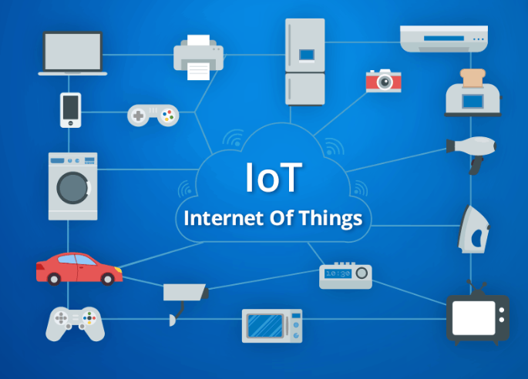

What is Internet of Things?

The internet of things (IoT) is the network of physical devices, vehicles, buildings and other items—embedded with electronics, software, sensors, and network connectivity that enables these objects to collect and exchange data.

Wikipedia

Gartner’s definition

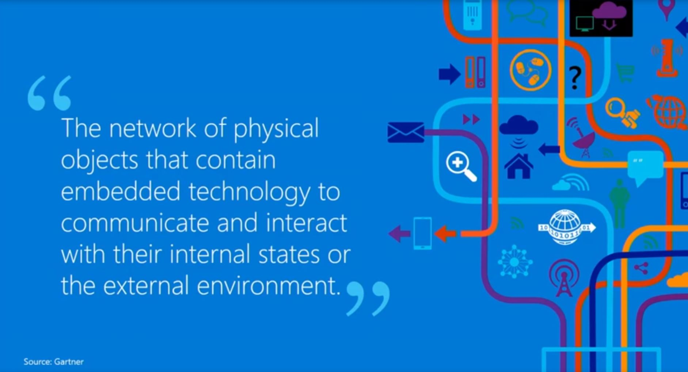

IBM

Watson Internet of Things. Cognitive Internet of Things will transform the way every person experiences the physical world.

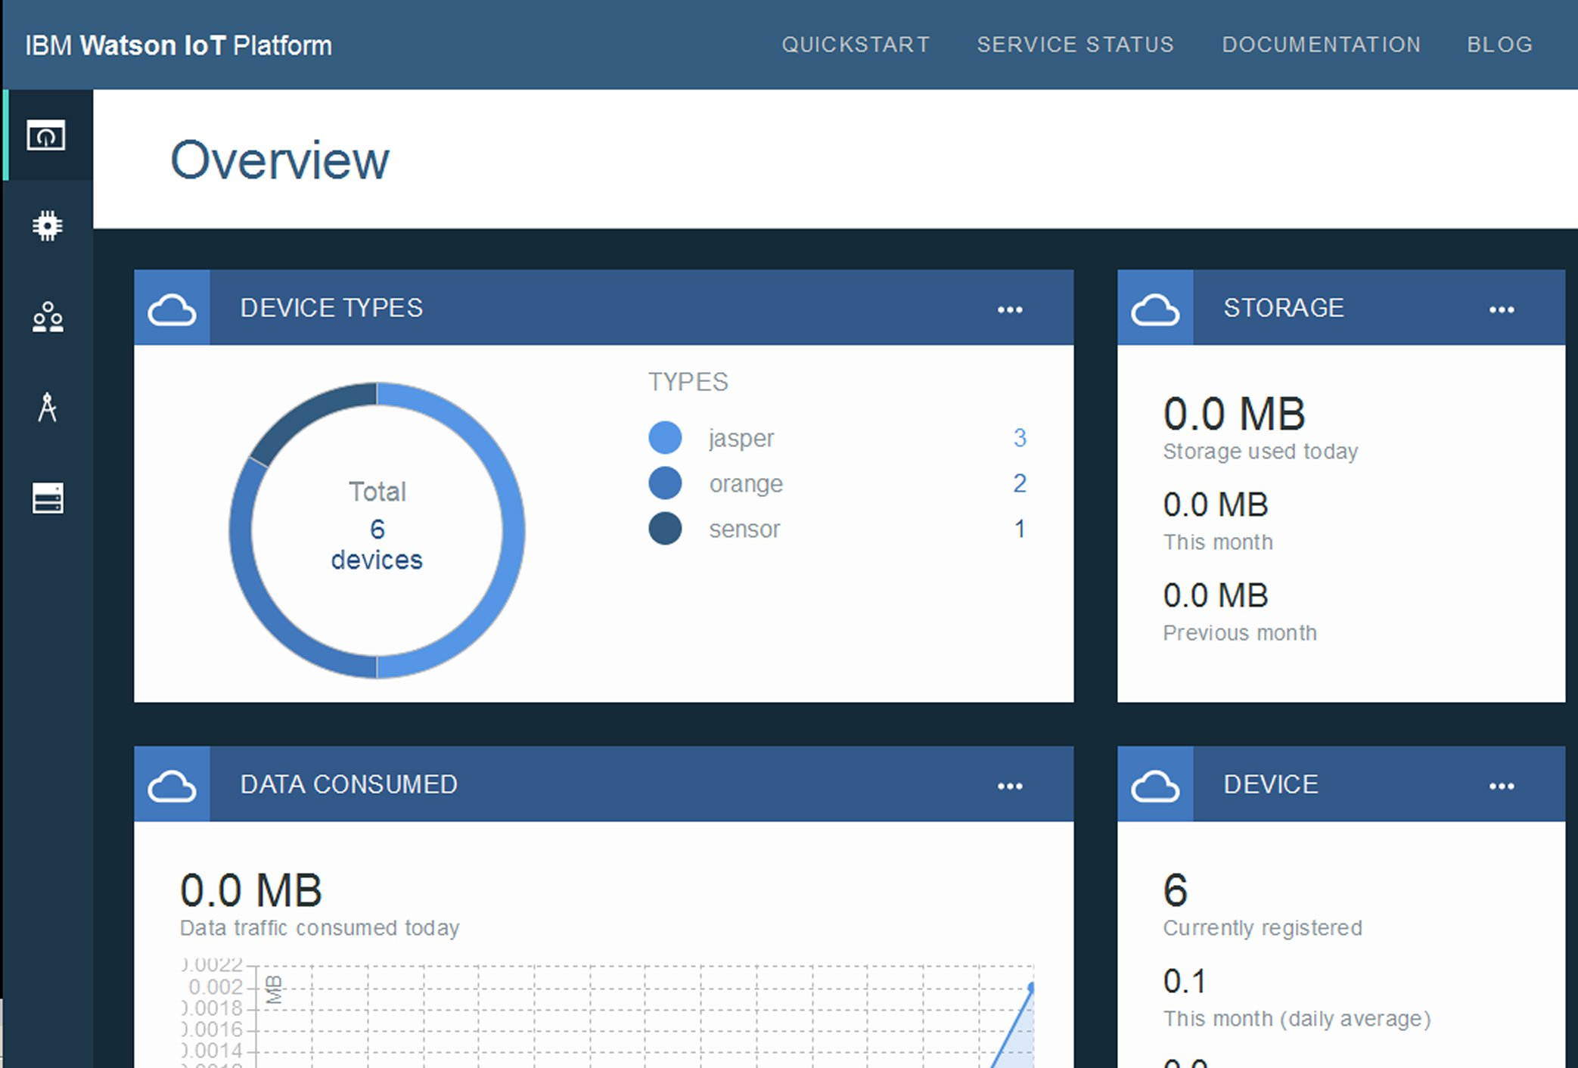

Google

Google Brillo. brings the simplicity and speed of software development to hardware for IoT with an embedded OS, core services, developer kit, and developer console.

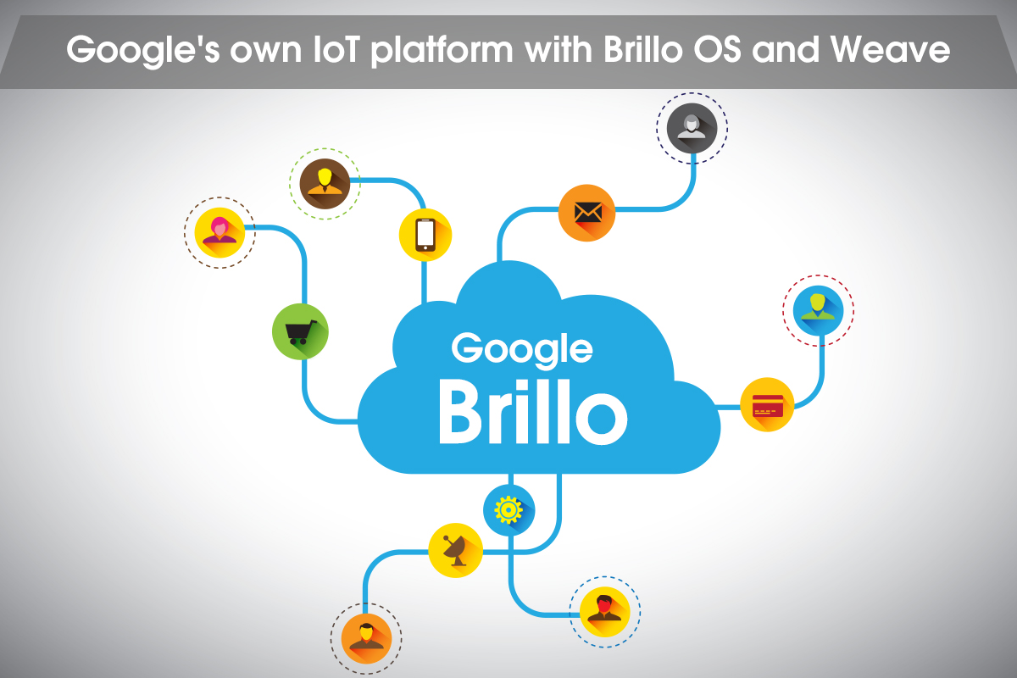

amazon

amazon AWS IoT. Easily and securely connect devices to the cloud.

Reliably scale to billions of devices and trillions of messages

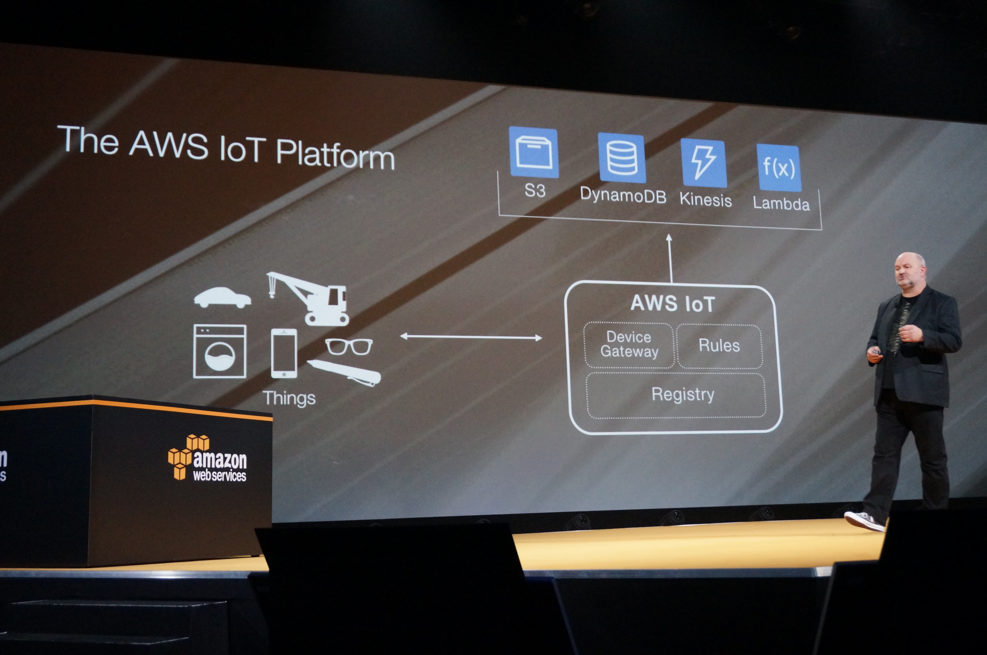

Microsoft

Microsoft Azure IoT Suite. Capture and analyze untapped data to improve business results

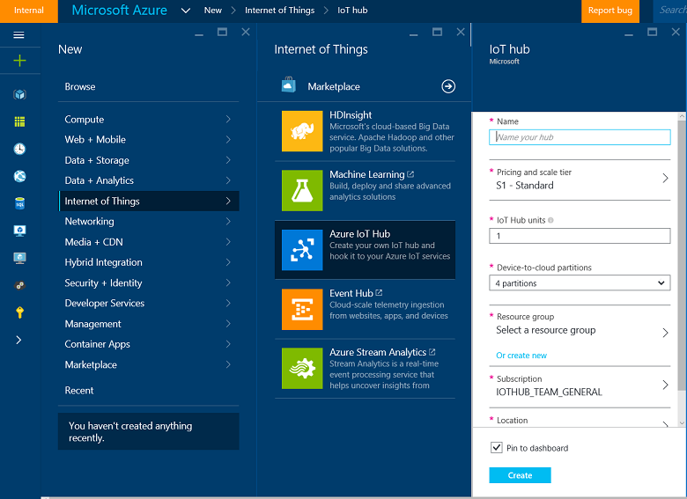

IoT Application

* Smart Cities
* Smart Environment
* Smart Water
* Smart Metering
* Security & Emergencies
* Retail
* Logistics
* Industrial Control
* Agriculture
* Animal Farming
* Domestic & Home Automation

Microsoft Azure Subscription

https://loy2art.blogspot.com/2019/03/microsoft-azure.html

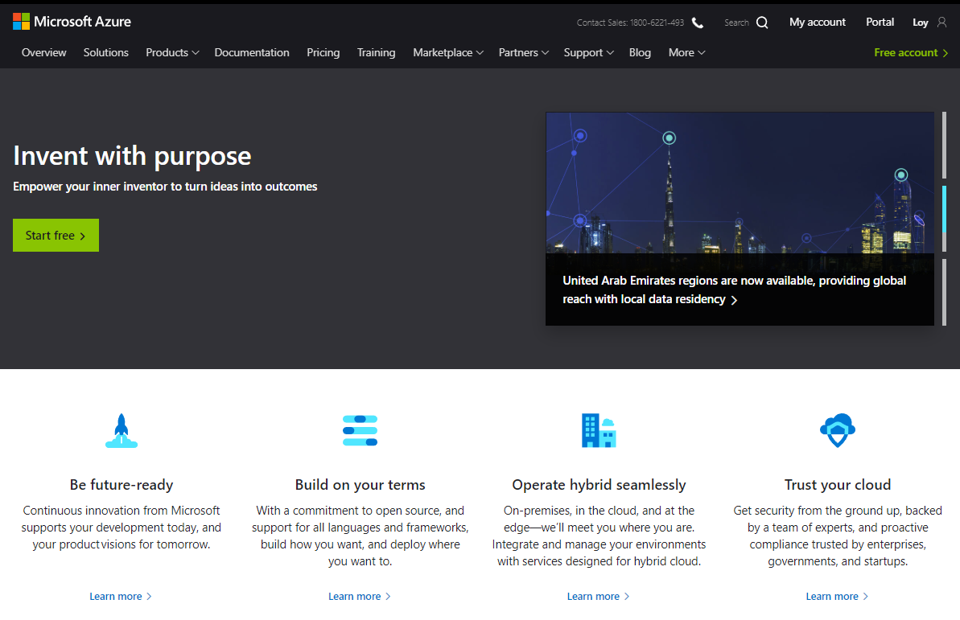

What's next?

